As the Detective:

3.40 pm

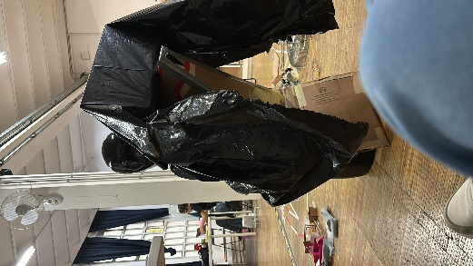

Vitti stayed in class, while everyone else left. She was wearing a black tshirt, blue jeans and really nice shade of red adidas shoes. She put her headphones on and was typing on her laptop at her desk. She is focused on what she’s doing .

3.49 pm

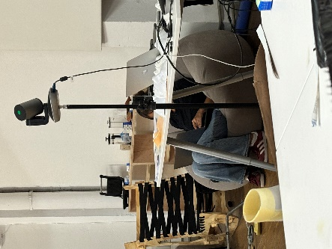

She shifted from her desk to the more comfortable bean bag. Looks like she is still working and has her headphones on. She is intently typing on her keyboard.

(I am trying to be nonchalant but I am clearly failing)

4.02 pm

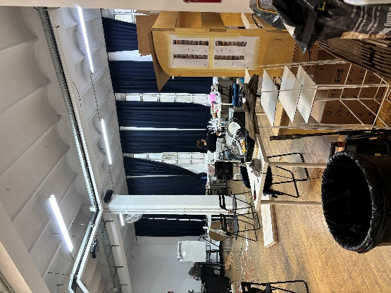

Vitti shifts back to her desk and continues working on her laptop. (I try to change my location to see what she’s working on better) After a few minutes, she calls me and asks me to sit with her. She wants to smoke but cant find her lighter. She assumes Andrea took it and never gave it back. Ramon walks in and Vitti asks him for the lighter. She invites me to accompany her to the terrace for a smoke

(I’m a bad detective, chilling with my own subject, lol)

4.08 pm

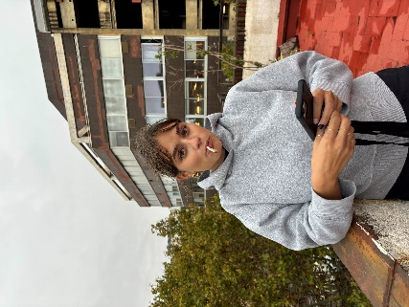

She lights up a cigarette and we talk about our brownie experience (thanks Max). We talk about our previous experiences about travelling to Varanasi which leads us to discussing about religion. She tells me she is brought up as Christian but would rather be agnostic. She finds it somewhat twisted that religion is used as a way to make money, playing on the feelings of people. She seems curious about understanding and reading about religion but would rather be free from it.

4.22 pm

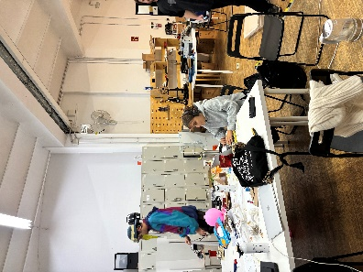

We are back in class just as everyone else arrives. I ask her what she has been working on, she tells me she’s working on the report and needs to finish it in time. She tells me she’s planning a graduation party for her cousin and will be flying home this weekend. Then she excuses herself to get back to work just as everyone else arrives to class.